**Practical 1**

**Aim: Design Bordered table for storing details of IT Department using bootstrap. Also highlight HOD of department.**

<!DOCTYPE html>

<html lang="en">

<head>

<title>Bootstrap Example</title>

<meta charset="utf-8">

<meta name="viewport" content="width=device-width, initial-scale=1">

<link rel="stylesheet" href="https://maxcdn.bootstrapcdn.com/bootstrap/3.3.7/css/bootstrap.min.css">

<script src="https://ajax.googleapis.com/ajax/libs/jquery/3.3.1/jquery.min.js"></script>

<script src="https://maxcdn.bootstrapcdn.com/bootstrap/3.3.7/js/bootstrap.min.js"></script>

</head>

<body>

<div class="container">

<h2>Bordered Table</h2>

<p>The .table-bordered class adds borders to a table:</p>

<table class="table table-bordered">

<thead>

<tr>

<th>Firstname</th>

<th>Lastname</th>

<th>Post</th>

</tr>

</thead>

<tbody>

<tr class="success">

<td>Amit Kumar</td>

<td>Dhaiya</td>

<td>HOD</td>

</tr>

<tr>

<td>Garima</td>

<td>Verma</td>

<td>Asst. Professor</td>

</tr>

<tr>

<td>Rupak</td>

<td>Chakarobarty</td>

<td>Asst. Professor</td>

</tr>

<tr>

<td>Nitin</td>

<td>Thapliyal</td>

<td>Asst. Professor</td>

</tr>

</tbody>

</table>

</div>

</body>

</html>

**OUTPUT**

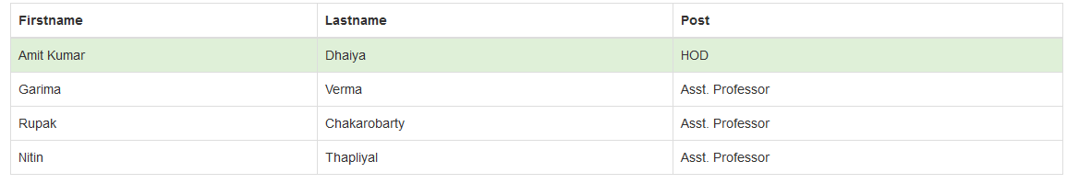

**Practical 2**

**Aim: Insert an image in different shape in a Webpage.**

<!DOCTYPE html>

<html lang="en">

<head>

<title>Bootstrap Example</title>

<meta charset="utf-8">

<meta name="viewport" content="width=device-width, initial-scale=1">

<link rel="stylesheet" href="https://maxcdn.bootstrapcdn.com/bootstrap/3.3.7/css/bootstrap.min.css">

<script src="https://ajax.googleapis.com/ajax/libs/jquery/3.3.1/jquery.min.js"></script>

<script src="https://maxcdn.bootstrapcdn.com/bootstrap/3.3.7/js/bootstrap.min.js"></script>

</head>

<body>

<div class="container">

<h2>Images</h2>

<p>The images:</p>

<imgsrc="cinqueterre.jpg" class="img-thumbnail" alt="Cinque Terre" width="304" height="236">

<imgsrc="cinqueterre.jpg" class="img-circle" alt="Cinque Terre" width="304" height="236">

<imgsrc="cinqueterre.jpg" class="img-rounded" alt="Cinque Terre" width="304" height="236">

</div>

</body>

</html>

**OUTPUT**

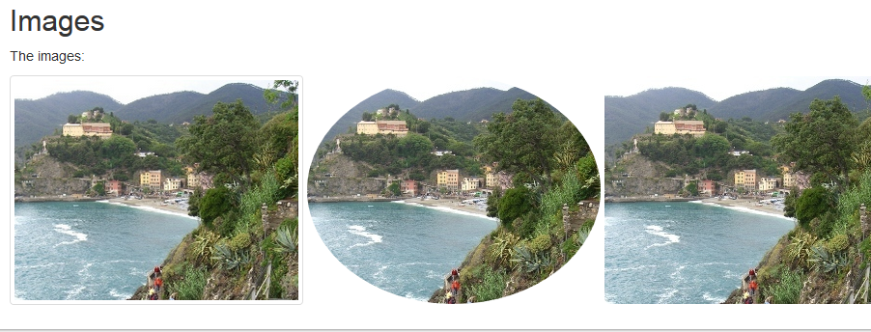

**Practical 3**

**Aim: Design login form using bootstrap classes.**

<!DOCTYPE html>

<html lang="en">

<head>

<title>Bootstrap Example</title>

<meta charset="utf-8">

<meta name="viewport" content="width=device-width, initial-scale=1">

<link rel="stylesheet" href="https://maxcdn.bootstrapcdn.com/bootstrap/3.3.7/css/bootstrap.min.css">

<script src="https://ajax.googleapis.com/ajax/libs/jquery/3.3.1/jquery.min.js"></script>

<script src="https://maxcdn.bootstrapcdn.com/bootstrap/3.3.7/js/bootstrap.min.js"></script>

</head>

<body>

<div class="container">

<h2>Basic form</h2>

<form action="/action_page.php">

<div class="form-group">

<label for="email">Email:</label>

<input type="email" class="form-control" id="email" placeholder="Enter email" name="email">

</div>

<div class="form-group">

<label for="pwd">Password:</label>

<input type="password" class="form-control" id="pwd" placeholder="Enter password" name="pwd">

</div>

<div class="checkbox">

<label><input type="checkbox" name="remember"> Remember me</label>

</div>

<button type="submit" class="btnbtn-default">Submit</button>

</form>

</div>

</body></html>

**OUTPUT**

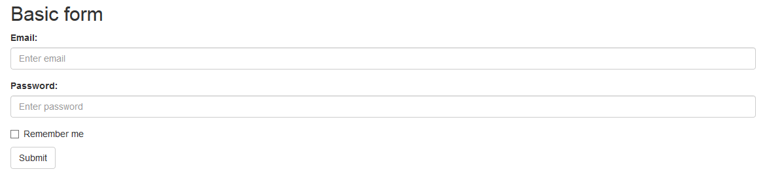

**Practical 4**

**Aim: Downloading and Installation of Ruby on Rails.**

Follow the steps given below for installing Ruby on Rails.

**Step 1: Check Ruby Version**

>>ruby –v

>> gem –version

**Step 2: Install Ruby**

**Install Rails** − With Rubygems loaded, you can install all of Rails and its dependencies using the following command through the command line –

C:\> gem install rails

### Step 3: Check Rails Version

C:\> rails –v

Rails 4.2.4

**Practical 5**

**Aim: Create module for simple calculator function.**

defcalculate_answer(operator, a, b)

if operator == "add"

a + b

elsif operator == "subtract"

a - b

elsif operator == "multiply"

a * b

elsif operator == "divide"

a / b

end

end

answer = calculate_answer("subtract", 11, 1)

puts "The answer is #{answer}"

**OUTPUT**

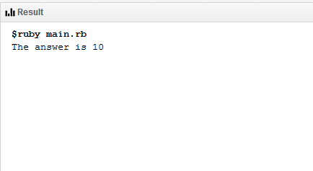

**Practical 6**

**Aim: WAP to calculate factorial of No. using Ruby.**

def factorial(n)

total = 1

(1..n).each do |n|

total *= n

end

total

end

puts factorial("4".to_i)

**OUTPUT**

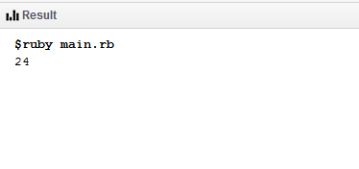

**Practical 7**

**Aim: WAP to show the implementation of Button, ToggleButton, Date-Time Picker etc.**

**activity_main.xml :**

<?xml version="1.0" encoding="utf-8"?>  
<LinearLayout  
xmlns:android="http://schemas.android.com/apk/res/android"  
xmlns:app="http://schemas.android.com/apk/res-auto"  
xmlns:tools="http://schemas.android.com/tools"  
android:layout_width="match_parent"  
android:layout_height="match_parent"  
android:orientation="vertical"  
tools:context=".MainActivity">  
  
<TextView  
android:layout_width="wrap_content"  
android:layout_height="wrap_content"  
android:text="Name: "  
android:textColor="#000"/>  
<EditText  
android:id="@+id/editText"  
android:layout_width="match_parent"  
android:layout_height="wrap_content"  
android:ems="10"  
android:inputType="time"  
tools:layout_editor_absoluteX="42dp"  
tools:layout_editor_absoluteY="232dp"/>  
  
<TextView  
android:layout_width="wrap_content"  
android:layout_height="wrap_content"  
android:text="Gender: "  
android:textColor="#000"/>  
<ToggleButton  
android:id="@+id/toggleButton"  
android:layout_width="wrap_content"  
android:layout_height="wrap_content"  
android:clickable="false"  
android:text="ToggleButton"  
android:textOff="Male"  
android:textOn="Female"  
tools:layout_editor_absoluteX="43dp"  
tools:layout_editor_absoluteY="37dp"/>  
  
<TextView  
android:layout_width="wrap_content"  
android:layout_height="wrap_content"  
android:text="DOB: "  
android:textColor="#000"/>  
<Button  
android:id="@+id/buttonDate"  
android:layout_width="wrap_content"  
android:layout_height="wrap_content"  
android:text="Select Date"/>  
<EditText  
android:layout_width="wrap_content"  
android:layout_height="wrap_content"  
android:id="@+id/textDate"/>  
  
<Button  
android:id="@+id/button"  
android:layout_width="wrap_content"  
android:layout_height="wrap_content"  
android:text="Show"  
tools:layout_editor_absoluteX="148dp"  
tools:layout_editor_absoluteY="398dp"/>  
<TextView  
android:layout_width="match_parent"  
android:layout_height="wrap_content"  
android:id="@+id/data"/>  
  
</LinearLayout>

**MainActivity.java :**

package app.bro.myapplication;  
  
import android.app.DatePickerDialog;  
import android.os.Bundle;  
import android.support.v7.app.AppCompatActivity;  
import android.view.View;  
import android.widget.Button;  
import android.widget.DatePicker;  
import android.widget.EditText;  
import android.widget.TextView;  
import android.widget.ToggleButton;  
  
import java.util.Calendar;  
  
public class MainActivity extends AppCompatActivity {  
 Button bShow, bDatePicker;  
EditTextetName, txtDate;  
ToggleButtontGender;  
TextView data ;  
 private intmYear, mMonth, mDay;  
  
 @Override  
 protected void onCreate(Bundle savedInstanceState) {  
super.onCreate( savedInstanceState );  
setContentView( R.layout.*activity_main*);  
bShow = ( Button ) findViewById( R.id.*button*);  
bDatePicker = ( Button ) findViewById( R.id.*buttonDate*);  
etName = ( EditText ) findViewById( R.id.*editText*);  
tGender = ( ToggleButton ) findViewById( R.id.*toggleButton*);  
txtDate = ( EditText ) findViewById( R.id.*textDate*);  
 data = (TextView) findViewById( R.id.*data*);  
 final String name = etName.getText().toString();  
 final String gender = tGender.getText().toString();  
 final String dob = txtDate.getText().toString();  
bShow.setOnClickListener( new View.OnClickListener() {  
 @Override  
 public void onClick(View view) {  
data.setText( name + ":" + gender + ":" + dob );  
 }  
 } );  
  
bDatePicker.setOnClickListener( new View.OnClickListener() {  
 @Override  
 public void onClick(View view) {  
 final Calendar c = Calendar.*getInstance*();  
mYear = c.get(Calendar.*YEAR*);  
mMonth = c.get(Calendar.*MONTH*);  
mDay = c.get(Calendar.*DAY_OF_MONTH*);  
  
  
DatePickerDialogdatePickerDialog = new DatePickerDialog( this,  
 new DatePickerDialog.OnDateSetListener() {  
 @Override  
 public void onDateSet(DatePicker view, int year, int month, intdayOfMonth) {  
txtDate.setText(dayOfMonth + "-" + (month + 1) + "-" + year);  
 }  
 }, mYear, mMonth, mDay );  
datePickerDialog.show();  
 } );  
 }  
}

**OUTPUT**

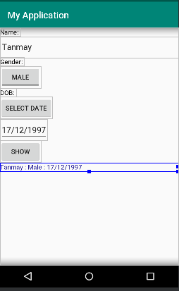

Akshat

**Practical 8**

**Aim: Create a Media Player Application in android.**

**activity_main.xml :**

<?xml version="1.0" encoding="utf-8"?>

<RelativeLayout xmlns:android="http://schemas.android.com/apk/res/android"

xmlns:tools="http://schemas.android.com/tools" android:layout_width="match_parent"

android:layout_height="match_parent"

android:paddingLeft="@dimen/activity_horizontal_margin"

android:paddingRight="@dimen/activity_horizontal_margin"

android:paddingTop="@dimen/activity_vertical_margin"

android:paddingBottom="@dimen/activity_vertical_margin" tools:context=".MainActivity">

<TextView android:text="Music Palyer" android:layout_width="wrap_content"

android:layout_height="wrap_content"

android:id="@+id/textview"

android:textSize="35dp"

android:layout_alignParentTop="true"

android:layout_centerHorizontal="true" />

<TextView

android:layout_width="wrap_content"

android:layout_height="wrap_content"

android:text="Tutorials point"

android:id="@+id/textView"

android:layout_below="@+id/textview"

android:layout_centerHorizontal="true"

android:textColor="#ff7aff24"

android:textSize="35dp" />

<ImageView

android:layout_width="wrap_content"

android:layout_height="wrap_content"

android:id="@+id/imageView"

android:layout_below="@+id/textView"

android:layout_centerHorizontal="true"

android:src="@drawable/abc"/>

<Button

android:layout_width="wrap_content"

android:layout_height="wrap_content"

android:text="@string/forward"

android:id="@+id/button"

android:layout_alignParentBottom="true"

android:layout_alignParentLeft="true"

android:layout_alignParentStart="true" />

<Button

android:layout_width="wrap_content"

android:layout_height="wrap_content"

android:text="@string/pause"

android:id="@+id/button2"

android:layout_alignParentBottom="true"

android:layout_alignLeft="@+id/imageView"

android:layout_alignStart="@+id/imageView" />

<Button

android:layout_width="wrap_content"

android:layout_height="wrap_content"

android:text="@string/back"

android:id="@+id/button3"

android:layout_alignTop="@+id/button2"

android:layout_toRightOf="@+id/button2"

android:layout_toEndOf="@+id/button2" />

<Button

android:layout_width="wrap_content"

android:layout_height="wrap_content"

android:text="@string/rewind"

android:id="@+id/button4"

android:layout_alignTop="@+id/button3"

android:layout_toRightOf="@+id/button3"

android:layout_toEndOf="@+id/button3" />

<SeekBar

android:layout_width="wrap_content"

android:layout_height="wrap_content"

android:id="@+id/seekBar"

android:layout_alignLeft="@+id/textview"

android:layout_alignStart="@+id/textview"

android:layout_alignRight="@+id/textview"

android:layout_alignEnd="@+id/textview"

android:layout_above="@+id/button" />

<TextView

android:layout_width="wrap_content"

android:layout_height="wrap_content"

android:textAppearance="?android:attr/textAppearanceSmall"

android:text="Small Text"

android:id="@+id/textView2"

android:layout_above="@+id/seekBar"

android:layout_toLeftOf="@+id/textView"

android:layout_toStartOf="@+id/textView" />

<TextView

android:layout_width="wrap_content"

android:layout_height="wrap_content"

android:textAppearance="?android:attr/textAppearanceSmall"

android:text="Small Text"

android:id="@+id/textView3"

android:layout_above="@+id/seekBar"

android:layout_alignRight="@+id/button4"

android:layout_alignEnd="@+id/button4" />

<TextView

android:layout_width="wrap_content"

android:layout_height="wrap_content"

android:textAppearance="?android:attr/textAppearanceMedium"

android:text="Medium Text"

android:id="@+id/textView4"

android:layout_alignBaseline="@+id/textView2"

android:layout_alignBottom="@+id/textView2"

android:layout_centerHorizontal="true" />

</RelativeLayout>

**MainActivity.java :**

package com.example.sairamkrishna.myapplication;

import android.app.Activity;

import android.media.MediaPlayer;

import android.os.Bundle;

import android.os.Handler;

import android.view.View;

import android.widget.Button;

import android.widget.ImageView;

import android.widget.SeekBar;

import android.widget.TextView;

import android.widget.Toast;

import java.util.concurrent.TimeUnit;

public class MainActivity extends Activity {

private Button b1,b2,b3,b4;

private ImageView iv;

private MediaPlayer mediaPlayer;

private double startTime = 0;

private double finalTime = 0;

private Handler myHandler = new Handler();;

private int forwardTime = 5000;

private int backwardTime = 5000;

private SeekBar seekbar;

private TextView tx1,tx2,tx3;

public static int oneTimeOnly = 0;

@Override

protected void onCreate(Bundle savedInstanceState) {

super.onCreate(savedInstanceState);

setContentView(R.layout.activity_main);

b1 = (Button) findViewById(R.id.button);

b2 = (Button) findViewById(R.id.button2);

b3 = (Button)findViewById(R.id.button3);

b4 = (Button)findViewById(R.id.button4);

iv = (ImageView)findViewById(R.id.imageView);

tx1 = (TextView)findViewById(R.id.textView2);

tx2 = (TextView)findViewById(R.id.textView3);

tx3 = (TextView)findViewById(R.id.textView4);

tx3.setText("Song.mp3");

mediaPlayer = MediaPlayer.create(this, R.raw.song);

seekbar = (SeekBar)findViewById(R.id.seekBar);

seekbar.setClickable(false);

b2.setEnabled(false);

b3.setOnClickListener(new View.OnClickListener() {

@Override

public void onClick(View v) {

Toast.makeText(getApplicationContext(), "Playing

sound",Toast.LENGTH_SHORT).show();

mediaPlayer.start();

finalTime = mediaPlayer.getDuration();

startTime = mediaPlayer.getCurrentPosition();

if (oneTimeOnly == 0) {

seekbar.setMax((int) finalTime);

oneTimeOnly = 1;

}

tx2.setText(String.format("%d min, %d sec",

TimeUnit.MILLISECONDS.toMinutes((long) finalTime),

TimeUnit.MILLISECONDS.toSeconds((long) finalTime) -

TimeUnit.MINUTES.toSeconds(TimeUnit.MILLISECONDS.toMinutes((long)

finalTime)))

);

tx1.setText(String.format("%d min, %d sec",

TimeUnit.MILLISECONDS.toMinutes((long) startTime),

TimeUnit.MILLISECONDS.toSeconds((long) startTime) -

TimeUnit.MINUTES.toSeconds(TimeUnit.MILLISECONDS.toMinutes((long)

startTime)))

);

seekbar.setProgress((int)startTime);

myHandler.postDelayed(UpdateSongTime,100);

b2.setEnabled(true);

b3.setEnabled(false);

}

});

b2.setOnClickListener(new View.OnClickListener() {

@Override

public void onClick(View v) {

Toast.makeText(getApplicationContext(), "Pausing

sound",Toast.LENGTH_SHORT).show();

mediaPlayer.pause();

b2.setEnabled(false);

b3.setEnabled(true);

}

});

b1.setOnClickListener(new View.OnClickListener() {

@Override

public void onClick(View v) {

int temp = (int)startTime;

if((temp+forwardTime)<=finalTime){

startTime = startTime + forwardTime;

mediaPlayer.seekTo((int) startTime);

Toast.makeText(getApplicationContext(),"You have Jumped forward 5

seconds",Toast.LENGTH_SHORT).show();

}else{

Toast.makeText(getApplicationContext(),"Cannot jump forward 5

seconds",Toast.LENGTH_SHORT).show();

}

}

});

b4.setOnClickListener(new View.OnClickListener() {

@Override

public void onClick(View v) {

int temp = (int)startTime;

if((temp-backwardTime)>0){

startTime = startTime - backwardTime;

mediaPlayer.seekTo((int) startTime);

Toast.makeText(getApplicationContext(),"You have Jumped backward 5

seconds",Toast.LENGTH_SHORT).show();

}else{

Toast.makeText(getApplicationContext(),"Cannot jump backward 5

seconds",Toast.LENGTH_SHORT).show();

}

}

});

}

private Runnable UpdateSongTime = new Runnable() {

public void run() {

startTime = mediaPlayer.getCurrentPosition();

tx1.setText(String.format("%d min, %d sec",

TimeUnit.MILLISECONDS.toMinutes((long) startTime),

TimeUnit.MILLISECONDS.toSeconds((long) startTime) -

TimeUnit.MINUTES.toSeconds(TimeUnit.MILLISECONDS.

toMinutes((long) startTime)))

);

seekbar.setProgress((int)startTime);

myHandler.postDelayed(this, 100);

}

};

}

**OUTPUT**

